Family Housing (Conkle Development)

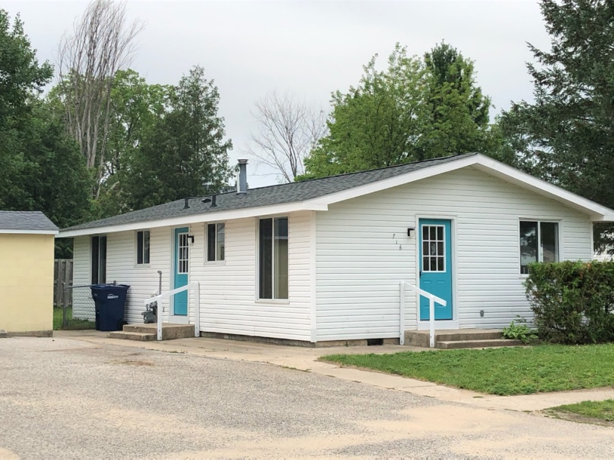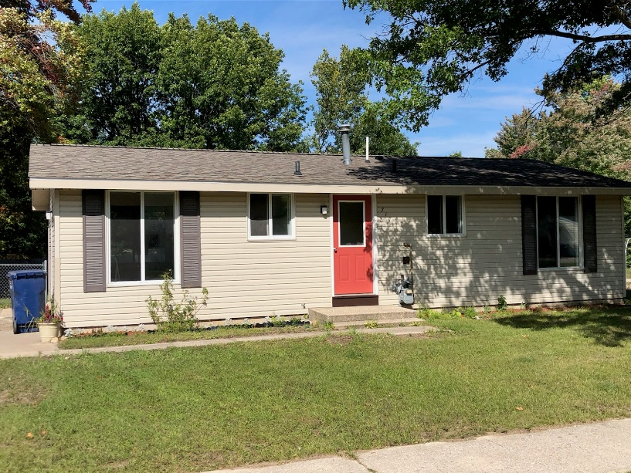

Named in honor of a pioneer physician of Charlevoix County, Conkle Development offers twenty-six high-quality rental homes throughout Boyne City. Our mission is to provide comfortable, affordable housing for families who meet HUD income guidelines.

Home Features & Amenities
- Spacious Layouts: Choice of two or three-bedroom floor plans.
- Full Kitchens: Equipped with a range, refrigerator, and dedicated dining area.
- Convenience: In-home utility areas with washer/dryer hook-ups and paved driveways.
- Storage & Outdoors: Private 5x10 storage sheds and many homes feature fenced-in backyards.
- Community: Access to a centrally located, fenced-in playground.
- Services Included: Weekly trash removal and water/sewer utilities are provided at no cost.

Leasing Information
Rent is designed to be affordable, typically calculated at approximately 30% of gross household income. Alternatively, flat rent options are available:
- 2-Bedroom: $1,039
- 3-Bedroom: $1,445

Tenants are responsible for electricity/heat, lawn care, and snow removal. To maintain a healthy environment, all Conkle Development housing is smoke-free.

A Note on the Future: We are currently in the planning stages for new housing developments to replace these units in the near future, continuing our commitment to quality housing in Boyne City. Keep an eye on the website at www.boynecityhc.org for updates on the development.

Boyne City Housing Commission (BCHC)
231-582-6203
www.boynecityhc.org

