Litzenburger Place Apartments
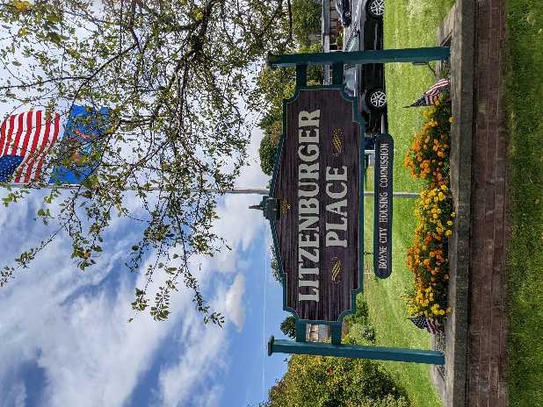

General-Occupancy Housing-Litzenburger Place offers 53 rental units open to all qualified applicants. We are a general occupancy community with no age restrictions.

Floor Plans & Sizes-We offer various one-bedroom layouts ranging from 485 to 575 sq. ft. Unit assignments are based on current availability.

Apartment Features:
- Private one-bedroom layouts
- Full kitchen with range and refrigerator
- Living and dining areas
- Ample closet storage
- Large bathroom with bathtub or shower unit

Rent & Utilities:
- Income-Based Rent: Monthly rent is typically 30% of gross monthly income (flat rent options available).
- Medical Deductions: Elderly or disabled households may deduct qualifying medical expenses from income.
- Utilities Included: Rent includes heat, water, and trash. (Electric is included for some units).

Amenities:
- Convenience: Two on-site laundry facilities, coin machines, and vending machines.
- Facilities: Indoor trash disposal and exercise equipment room.
- Community: Library, computer room, and a large community room with a full kitchen available for tenant use.

Boyne City Housing Commission
www.boynecityhc.org
231-582-6203
Equal Housing Opportunity

